**A look into the work of an online teacher: Mr. Merrick’s experiences.**

**Faisal Khreis**

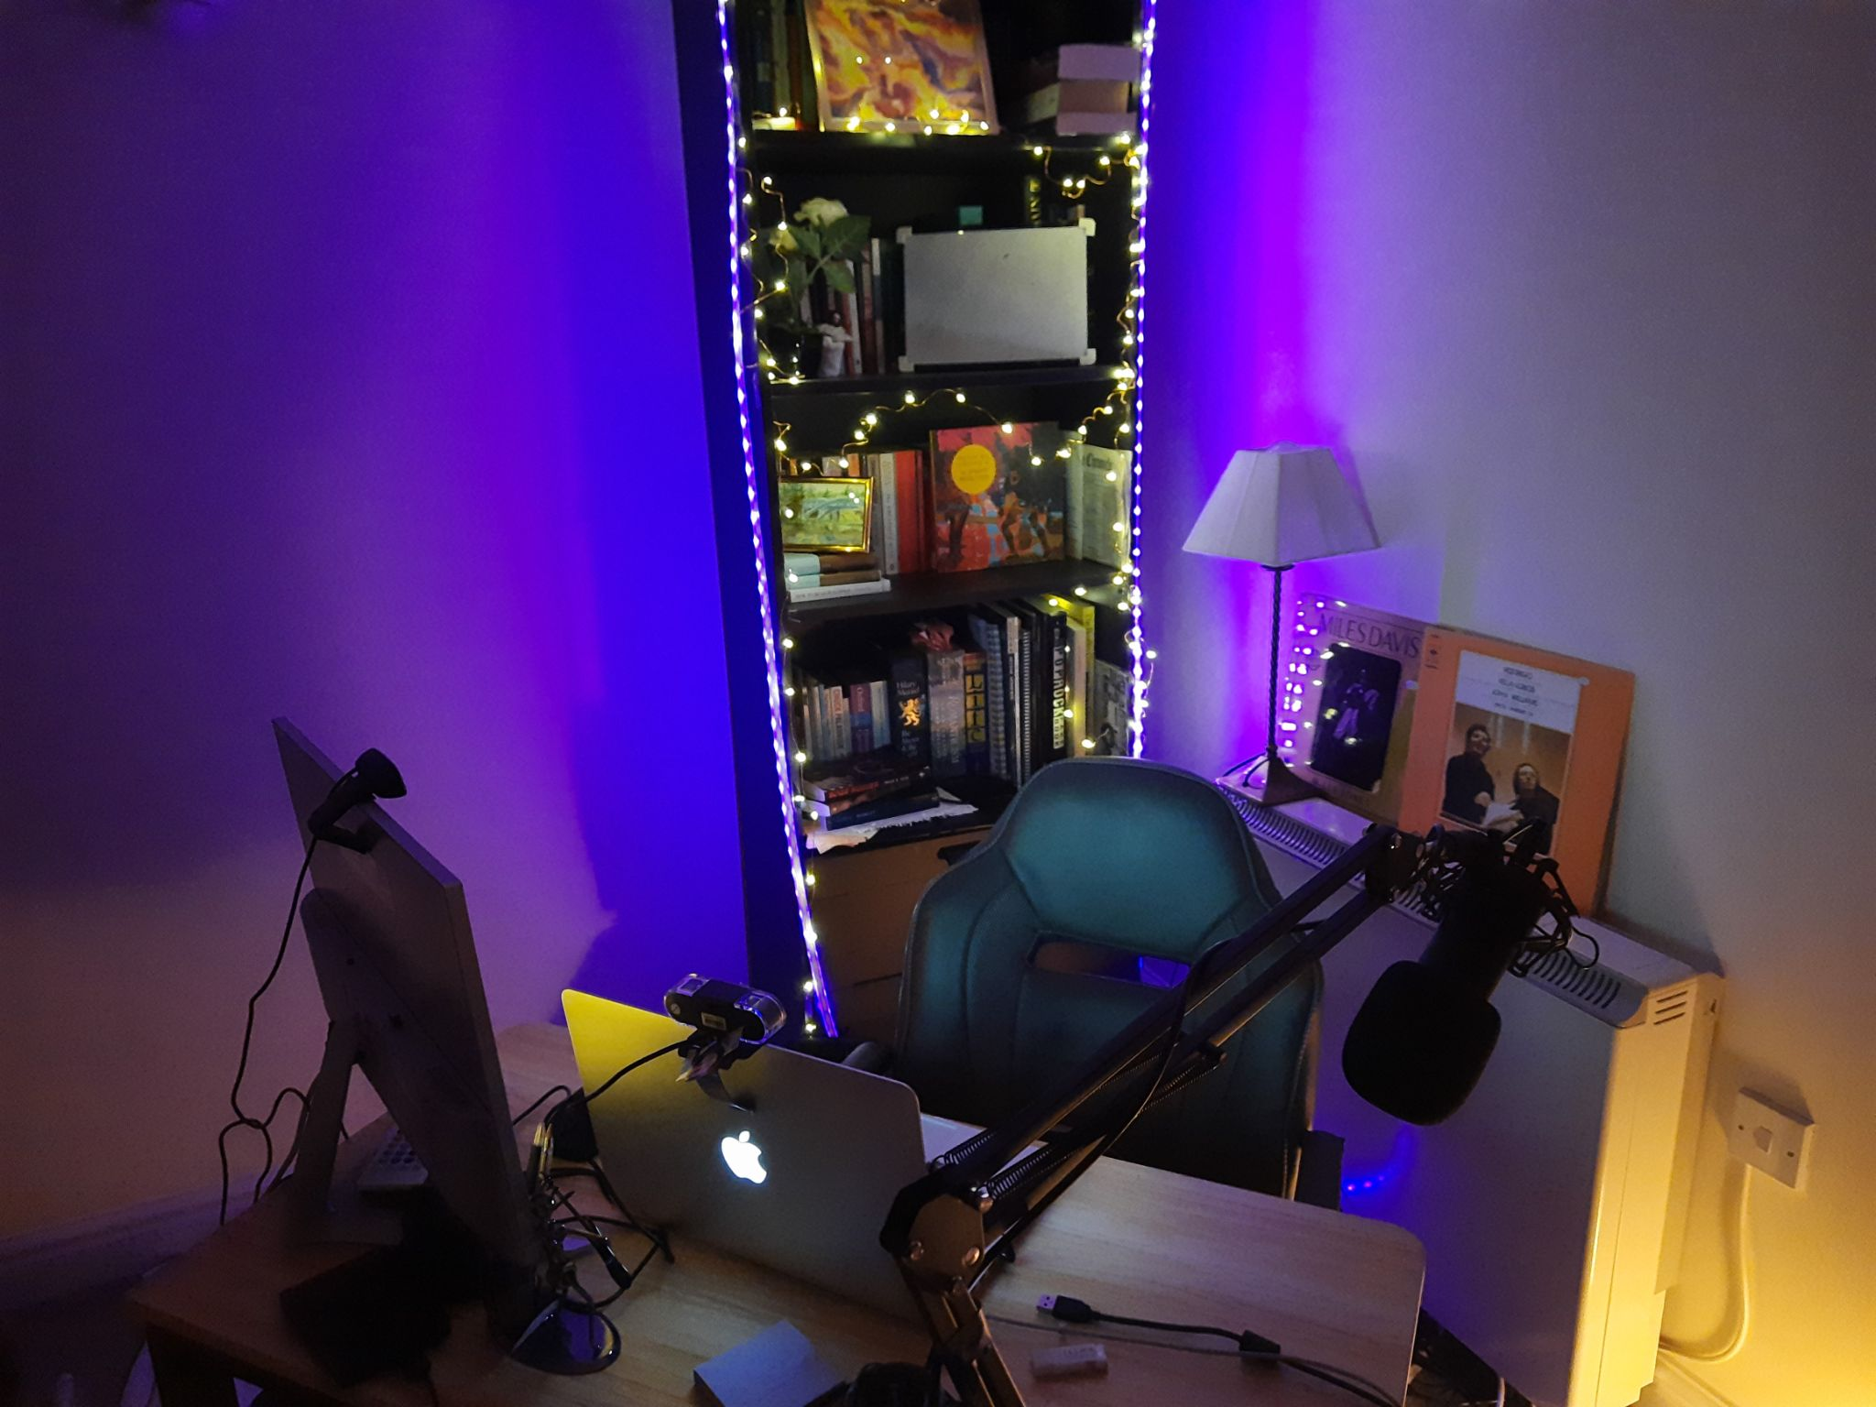

As a new, unique academic year dawned upon us, BISB’s well-rounded English department found themselves gaining yet another excellent teacher, Mr. Benjamin Merrick. However, due to the COVID-19 pandemic that has impacted many aspects of our lives, Mr. Merrick still resides in the UK, some 3,000 miles away from his new place of work. Despite the significant physical distance, the many students taught by Mr. Merrick still benefit greatly from his teaching expertise and the unique teaching styles and approaches he chooses to employ in his lessons.

How has he managed to keep teaching at such a high level during a pandemic? Well, Mr. Merrick expressed his pre-existing love for technology, stating that “[he and Mr. Nicholas had] talked at length about the role that technology plays in classrooms.” In addition to the fact that “[he’d] always been interested in using technology in interesting ways, from making animations, to coding games that students can play on for the purposes of learning.” It’s evident that Mr. Merrick is no stranger to implementing technology into his lesson plans, and because of this, he “embraced the opportunity to be a remote teacher, but of course, it’s not something that you would ever plan for.”

As part of his new position, Mr. Merrick has been “having fun messing around with features that have a high educational yield.” He has been busy, “creating interactive games for middle school, animating endgames, and making it so that the students can interact with one another.” While with high school, “[he and the students] have been collaborating in real time.” Mr. Merrick cited an instance where he “gave Year 11s a scaffold for a revision resource - it was totally blank - and within the space of about 15 minutes of [the class] working together, they made a really high quality study guide.”

Below are two notable examples of the impressive games designed by Mr. Merrick:

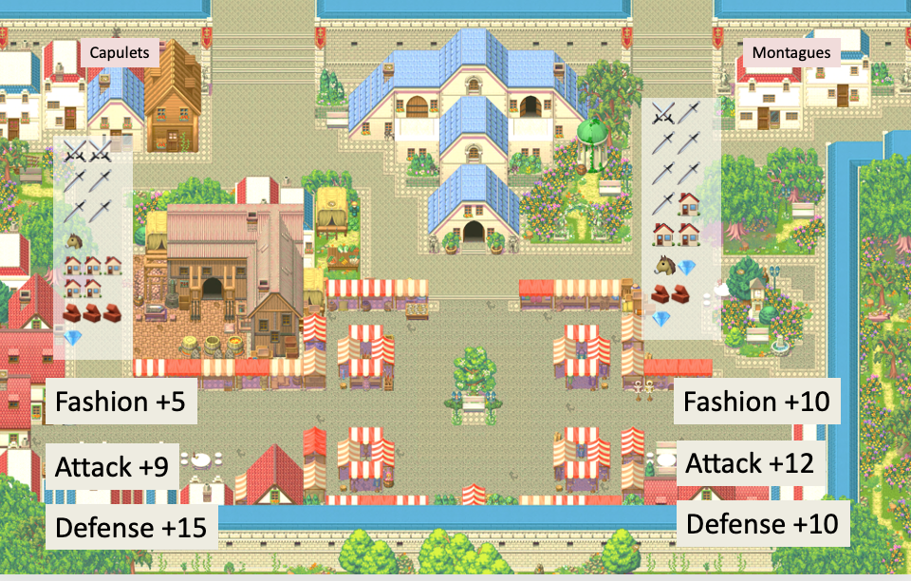

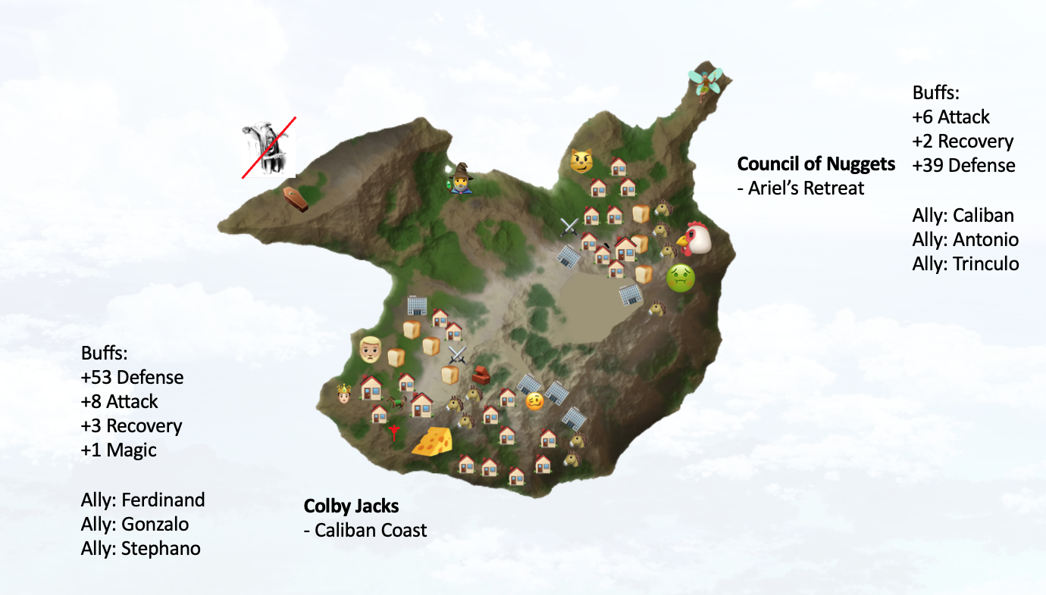

But it was not solely technology-related realizations that had struck Mr. Merrick as part of his online teaching experience. Teaching behind a screen made Mr. Merrick realize “how much of a sensory environment the classroom truly is.” He notes that while in a classroom, “you get distracted by the energy of others, and you feed off their energy. You get distracted by anybody’s slight facial expression, or somebody walking down the corridor.”

Planning seems to be a significant part of the online teaching experience, on many days, Mr. Merrick said, “I wake up at 7AM - this normally would be late, for a regular work day, but considering the fact that I start teaching at 1PM, it’s rather early.” From there, “I started planning at 7.30AM, and stopped at around 12.45PM.” All of his extensive planning is put into action between the hours of 1PM and 8.30PM, where he teaches students from middle school, all the way up into high school.

“It’s a huge sacrifice in terms of planning and time, but it’s important to keep in mind that so many other communities and people have made greater sacrifices, so I see it as nothing more than doing my part.” Says Mr. Merrick.

When asked about the online environment’s impact on the student-teacher relations that we value in our everyday academic interactions with our teachers, Mr. Merrick asked me to comment on what I noticed the student-teacher relations were like in my own SL Language and Literature class, to which I responded with: “I would personally say that there was no [negative] effect, if anything, our circumstances have stressed the importance of student-teacher relations. This means that we focus more on the conversations we have, and I believe it increased the importance of the fruitful, and the - sometimes distracting - comments we hear in class.”

Mr. Merrick believes that “the momentum of [his] lesson depends entirely on bridging the gap between the students being in-person, and [him] being online.” With that, Mr. Merrick emphasizes the importance of “focusing on the learning and the conversations themselves.”

In terms of what technology has allowed him to do, Mr. Merrick has been able to “have a lot of fun with the formatting of the lessons.” By devising creative presentations to represent textual themes, Mr. Merrick has been “making the best of [this] situation to make for a high-fidelity environment.”

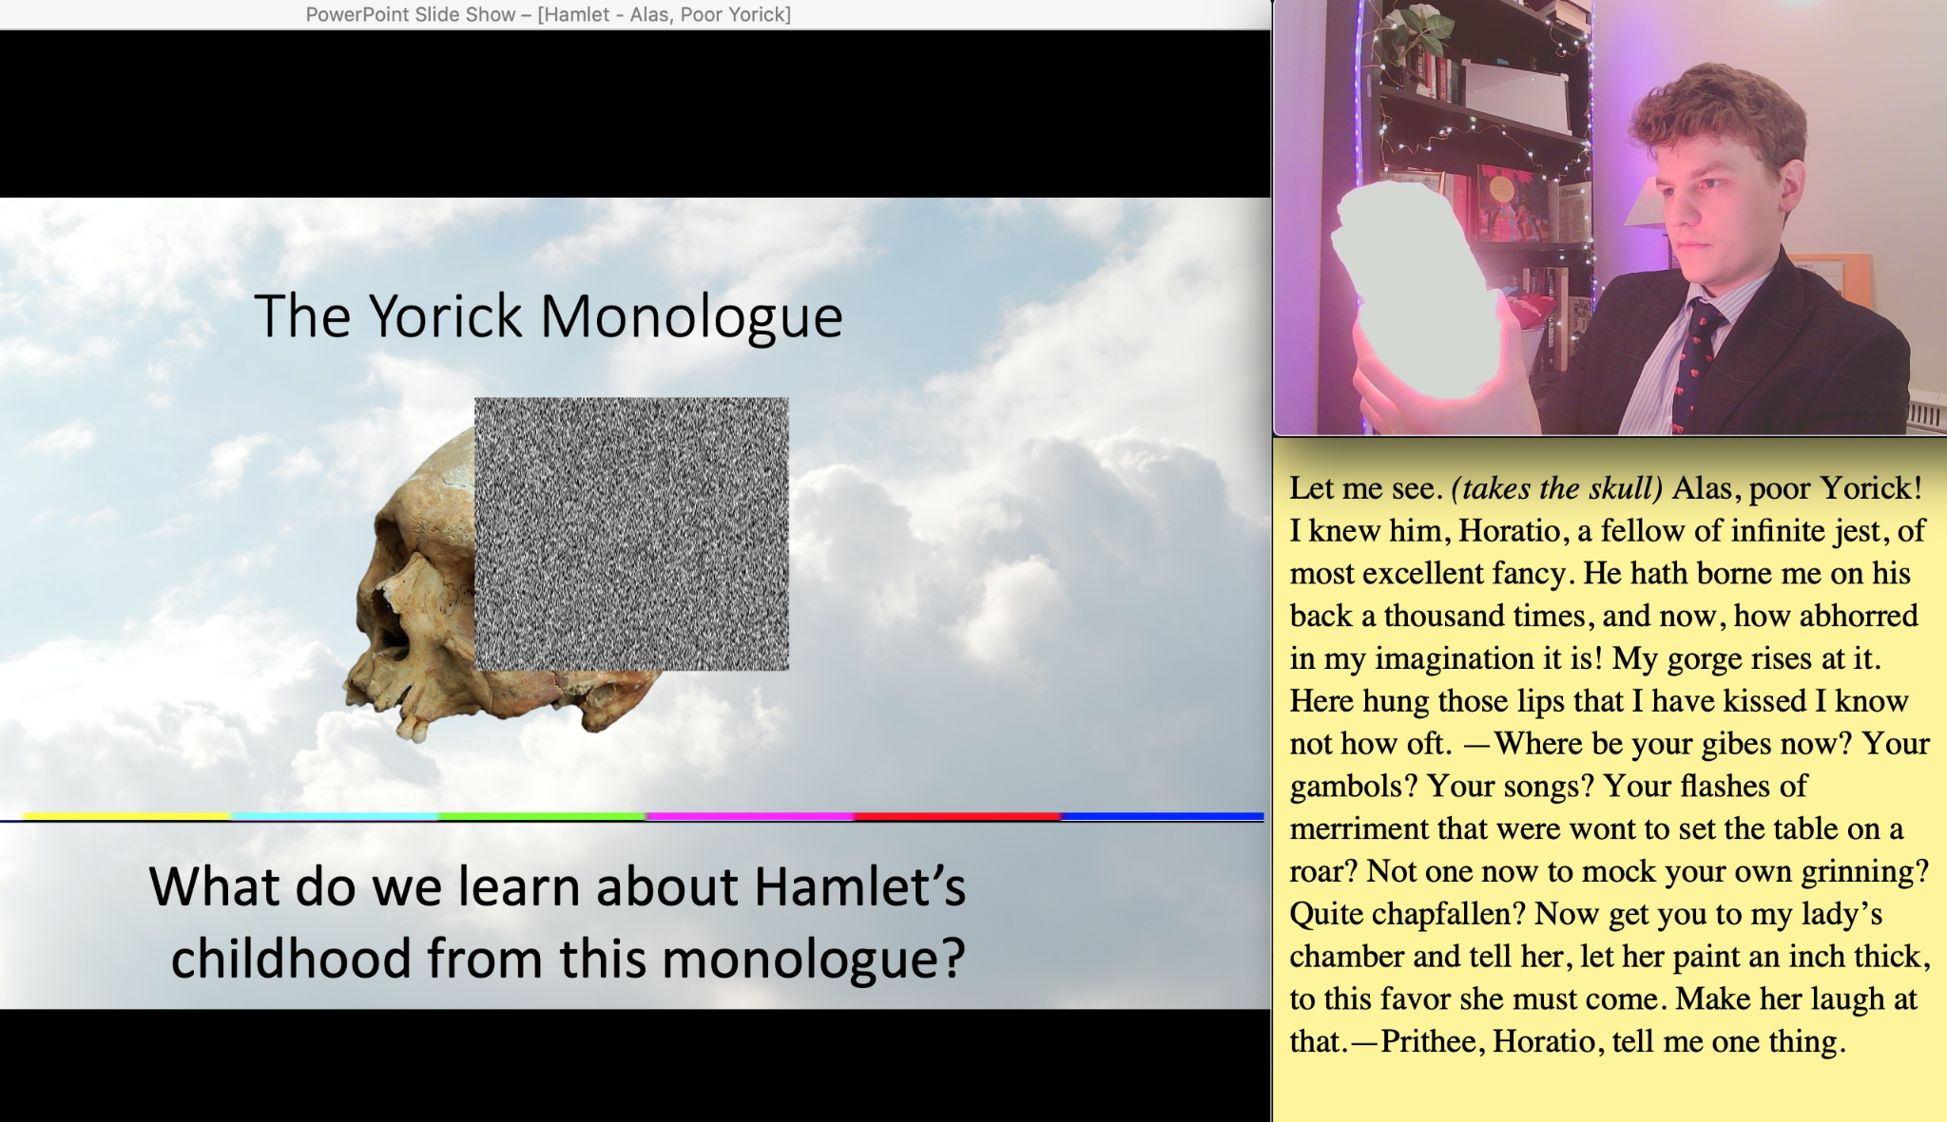

One of Mr. Merrick’s lessons where he is teaching about Shakespeare’s Hamlet.

Mr. Merrick’s camera transmits a very creative and dynamic background. His trademark black bookshelf carries books “that [he] actually reads, unlike the people you see on the news who pretend to read the books behind them.” As Mr. Merrick walked me through the remainder of the wonders housed by his shelf, such as his “colored LED lights, ever-changing whiteboard with the postmodern cat, and music records.” Even these smaller elements of Mr. Merrick’s online learning environment contribute to the fruitful conditions his students learn in.

On behalf of the student body and BISB, we all look forward to Mr. Merrick’s arrival in Boston, and while we will miss the highly-creative virtual environment, we are eager to welcome Mr. Merrick into our community in-person.

[End of article]

So it’s evident that while the sensory stimuli of the everyday classroom is not as prominent within Mr. Merrick’s online learning environment, the clarity of messaging between himself and his students is vastly improved, which can often lead to enhanced pieces of work, as with the Year 11 study guide. In addition to that, he “know[s] how difficult it is for [in-person teachers] to teach a group of students who are all wearing masks, and this profoundly changes reading facial expressions.” Because of this, Mr. Merrick knows that teachers “have to plan around that, the same way that when you’re teaching remotely, you have to spend a lot more time planning your lessons than you used to.”